# Update Derbynet and Raspberry Pi Devices

# Introduction

Updating the Derbynet Server and Raspberry Pi devices should be done once a year before the race. This should be done a couple of weeks before the race, I would highly recommend once updated and validated everything works, do not update again until next year. The only exception is if there is an issue, and the update is known to fix the issue.

# Validate Pre-Update

Before doing an update, you want to make sure everything is working this would include:

* Derbynet webpage (<https://pack442.coughlinfam.com>).
  + Spot check to make sure all menu areas are working.
* Connectivity from the Raspberry Pi to the Derbynet webpage.
* Kiosks (Start Monitor, Car Table, Replay Station, registration) are functioning.

This is not a requirement but a suggestion, if you have checked the setup in the past, after a last update you can skip this step.

# Update Derbynet Server

1. Launch **Oracle Virtualbox Manager**.
2. Right click on the **DerbyNetserver >** Click **Start >** Click **Normal Start**.

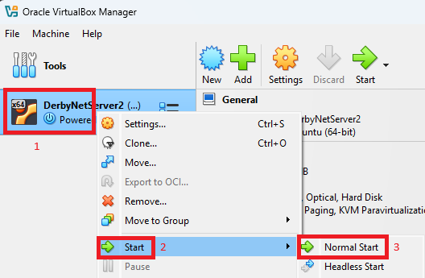

1. Login to the server

1. Type **sudo apt-get update** and press **Enter**.

1. Type **sudo apt list –upgradeable** and press **Enter**. This will show you what will be upgraded. Check for derbynet-server, nginix, make a note if you see either one of those on what you’re upgrading from / to. To check out the release notes for Derbynet go to: https://derbynet.org/builds/.

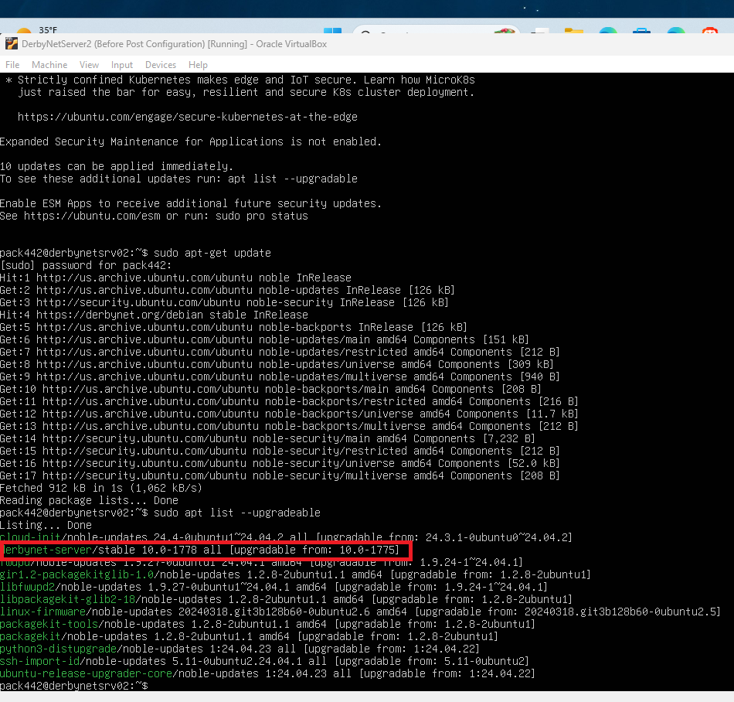

1. Press **Y** and press **Enter**.

1. Wait for the installation to finish, once done you will get a similar screen.

1. Continue to the Raspberry Pi Update.

# Raspberry PI Update

1. For the Raspberry Pi, you will follow Step 3 – 7, you can do this from the keyboard / mouse or if you’re an advanced user you can ssh to it and perform those steps.
2. Continue to the validate Post-Update Steps.

# Validate Post-Update

After doing an update, you want to make sure everything is working this would include:

* Derbynet webpage (<https://pack442.coughlinfam.com>).
  + Spot check to make sure all menu areas are working.
* Connectivity from the Raspberry Pi to the Derbynet webpage.
* Kiosks (Start Monitor, Car Table, Replay Station, registration) are functioning.